**­CMIS 320 Project 4**

Examine the following relation and its attributes and answer the following questions. Assume these are the values for “all time”. Assume girls with the same name are the same person.

|  |  |  |  |  |  |
| --- | --- | --- | --- | --- | --- |
| **GIRL** | **GROUP** | **AGE** | **GAME** | **CATEGORY** | **PRICE** |
| Charlotte | 5 year olds | 5 | Mirror | Makeup | 4.88 |
| Susan | 6 year olds | 6 | Lipstick | Makeup | 5.95 |
| Jane | 5 year olds | 5 | Chess | Games | 7.55 |
| Susan | 6 year olds | 6 | Checkers | Games | 5.95 |
| Susan | 6 year olds | 6 | Mirror | Makeup | 4.88 |
| Carrie | 6 year olds | 6 | Lipstick | Makeup | 5.95 |
| Jacqueline | 5 year olds | 5 | Visual Basic | Prog. Languages | 199.99 |

For each question below, please be sure to review the course content for additional reference material.

1. Is this relation in at least 1NF? Why or why not?

This relation is in First Normal Form because each attribute has atomic data. In other words, every field has one and only one piece of data in it. Each individual point of data has been broken out into its own column.

1. What is the primary key of the initial relation (assume the values shown are the only possible tuples for all time)? Remember that a primary key must be unique and not null.

Based on the provided table, we don’t have an entity that contains a unique value which is different from any other girls. Hence, let’s consider creating a primary key based on three significant entities: Girl, Age, and Game. The entity in which will contain the primary key would be called Girl ID, which links to the girl’s name, age, and game. This could uniquely identify all the other entities in the table.

1. Describe the specific data anomalies that exist if we DELETE the tuple containing Jacqueline.

Deleting the tuple containing Jacqueline will result in losing other attributes such as Category: Prog. Languanges and Game: Visual Basic.

1. Draw a functional dependency diagram for the initial relation. This diagram should agree with the primary key you selected in above. This can be drawn in any drawing tool.

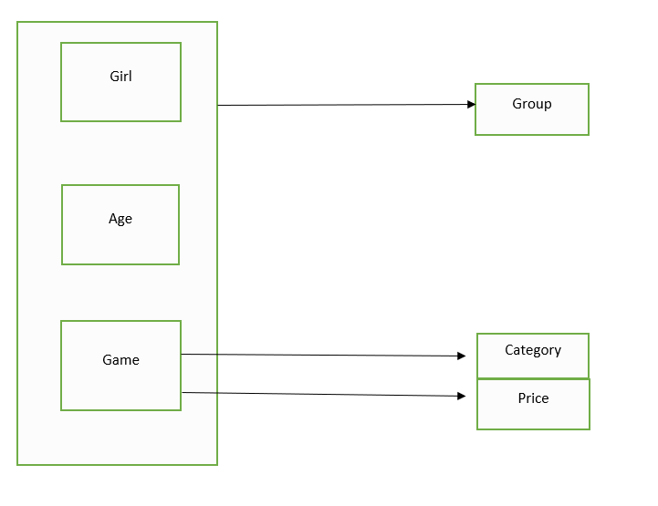

1. Based on your diagram, what normal form is the initial relation in? Why?

The relation of the above entities (Girl, Group, Age, Game, Category, and Price) is in first normal form because of its partial dependencies.

1. If necessary, decompose the initial relation into a set of non-loss 3NF relations by showing the relations, attributes, and tuples. Show complete relations with attribute headings and all data values in the tuples of your relations. Determine the number of 3NF relations you end up with after normalization, write this number, and then circle the number.

Before a relation can be in third normal form, we must convert the current relation to second normal form where no transitive dependencies exist. Looking at the first diagram, we need to divide the Game table with attributes Category and Price.

Girl (**Girl**, Group, Age, **Game**) Game (**Game**, **Category**, Price)

**Girl:**

|  |  |  |  |
| --- | --- | --- | --- |
| **Girl** | **Group** | **Age** | **Game** |
| Charlotte | 5 year olds | 5 | Mirror |
| Jane | 5 year olds | 5 | Chess |
| Jacqueline | 5 year olds | 5 | Visual Basic |
| Carrie | 6 year olds | 6 | Lipstick |
| Susan | 6 year olds | 6 | Lipstick |
| Susan | 6 year olds | 6 | Checkers |
| Susan | 6 year olds | 6 | Mirror |

**Game:**

|  |  |  |
| --- | --- | --- |
| **Game** | **Category** | **Price** |
| Mirror | Makeup | 4.88 |
| Chess | Game | 7.55 |
| Visual Basic | Prog. Languages | 199.99 |
| Lipstick | Makeup | 5.95 |
| Checkers | Game | 5.95 |

We have removed the transitive dependencies in the second normal form. We now convert the relation to third normal form to get the following:

Girl (**Girl**, **Age**, **Game**) Age-Group (**Age**, Group) Game (**Game**, Category, Price)

We now have relations in third normal form

**Girl:**

|  |  |  |
| --- | --- | --- |
| **Girl** | **Age** | **Game** |
| Charlotte | 5 | Mirror |
| Jane | 5 | Chess |
| Jacqueline | 5 | Visual Basic |
| Carrie | 6 | Lipstick |
| Susan | 6 | Lipstick |
| Susan | 6 | Checkers |
| Susan | 6 | Mirror |

**Age-Group:**

|  |  |
| --- | --- |
| **Age** | **Group** |
| 5 | 5 years of age |
| 6 | 6 years of age |

**Game:**

|  |  |  |
| --- | --- | --- |
| **Game** | **Category** | **Price** |
| Mirror | Makeup | 4.88 |
| Chess | Game | 7.55 |
| Visual Basic | Prog. Languages | 199.99 |
| Lipstick | Makeup | 5.95 |
| Checkers | Game | 5.95 |